Unwrought Bestiary Entry: The Unwrought Emperor
“The Origin of the Unwrought” – Final Sovereign of the Rift

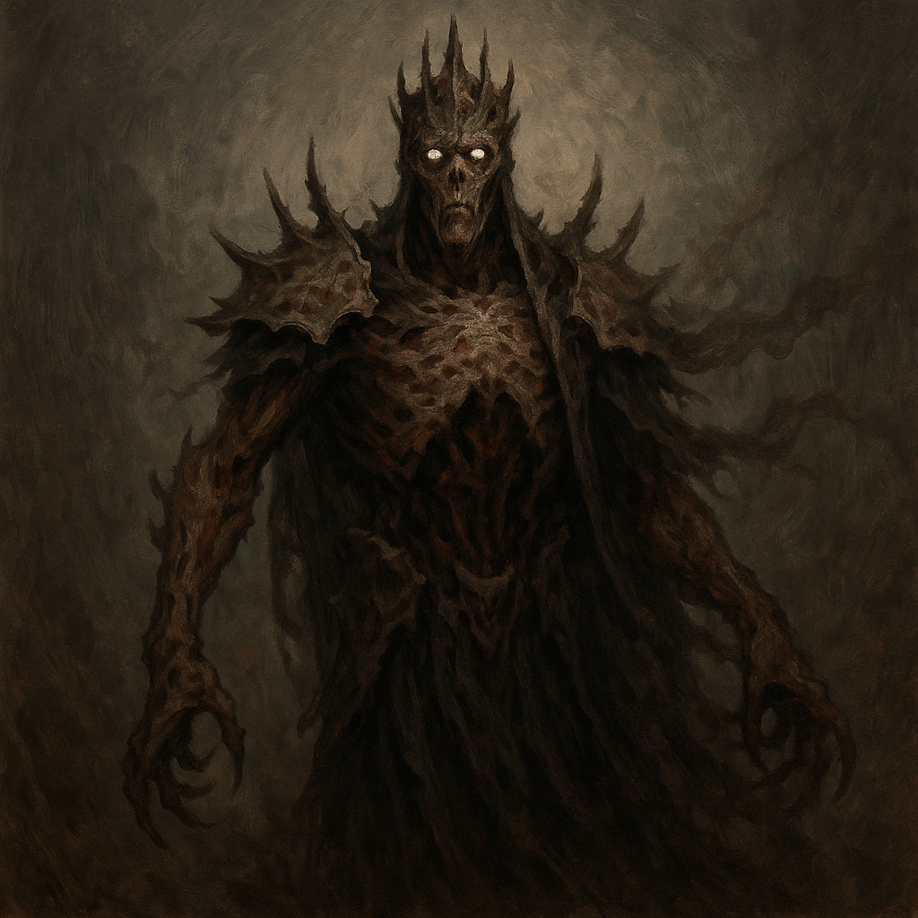

Description
The Unwrought Emperor is not merely a creature — it is a singularity. A god-machine born of forgotten rituals and corrupted leyline essence, sealed in the heart of the Rift Kingdom. His body is a towering amalgamation of armor, flesh, and the void, barely bound together by pulsing leyline chains.
He does not speak. He does not sleep. His presence alone warps the world, unraveling the threads of reality. Through him, all Unwrought are birthed. If he is destroyed, the entire legion crumbles.
No living soul has returned from seeing him. And should he awaken fully… Kaelithar will fall.

Stat Block (The Unwrought Emperor – CR 20)
**Armor Class**: 22 (void-forged throne-armor)
**Hit Points**: 350 (25d12 + 175)
**Speed**: 40 ft., teleport 60 ft.
**STR** 26 (+8) **DEX** 10 (+0) **CON** 24 (+7) **INT** 20 (+5) **WIS** 20 (+5) **CHA** 18 (+4)
**Saving Throws**: Str +15, Con +14, Wis +12, Cha +11
**Damage Resistances**: All nonmagical; immune to necrotic, psychic, and poison
**Condition Immunities**: Frightened, Charmed, Stunned, Paralyzed
**Senses**: Truesight 120 ft., passive Perception 15
**Languages**: Speaks through all Unwrought; understands all languages telepathically
**Challenge**: 20 (25,000 XP)

Abilities
**Unwrought Core.** While the Emperor lives, all Unwrought within 1 mile gain advantage on saving throws and attacks. Upon his death, all Unwrought in Kaelithar turn to ash.
**Void Pulse (Recharge 5–6).** A surge of black energy pulses out in a 60 ft. radius. All creatures must make a DC 20 Constitution saving throw or take 45 (10d8) necrotic damage and be blinded for 1 minute.
**Fracture Reality.** Once per long rest, the Emperor warps a 30 ft. cube of space into chaotic rift terrain. Time slows, light distorts, and gravity becomes unstable. Creatures inside must succeed a DC 18 Wisdom save or lose their next action.
**Leyline Rebirth.** When reduced to 0 HP, the Emperor may instead restore himself to 150 HP once, unless a Radiant or Force spell is used to sever his core mid-fight (DC 20 Arcana to target).
**Legendary Resistance (3/Day).** If the Emperor fails a saving throw, he can choose to succeed instead.

Actions
**Cataclysmic Slam.** *Melee Weapon Attack:* +14 to hit, reach 15 ft., one target.
*Hit:* 32 (4d10 + 8) bludgeoning damage and the target is knocked prone.
**Void Chain.** *Ranged Spell Attack:* +11 to hit, range 120 ft., one target.
*Hit:* 22 (4d8 + 4) force damage and the target is restrained until the end of its next turn.

Legendary Actions
The Unwrought Emperor can take 3 legendary actions, choosing from the options below. Only one legendary action can be used at a time and only at the end of another creature’s turn.
- **Chain Pull.** Force a creature within 60 ft. to make a DC 18 Strength save or be pulled 30 ft. closer.
- **Rift Glare.** A creature within 30 ft. must succeed on a DC 16 Charisma save or be frightened for 1 turn.
- **Command Legion.** All Unwrought allies within 120 ft. can immediately move up to 15 ft. and make one weapon attack.

Tactical Use
The Unwrought Emperor is a final boss designed for epic-scale conflict. He is a siege unto himself, capable of commanding legions and warping reality around him. He should be used in a multi-phase encounter, possibly beginning as a dormant statue before awakening. Use his abilities to pressure casters, punish clustered formations, and challenge even the most prepared parties.
To truly defeat him, the players must exploit his vulnerabilities and sever his leyline heart mid-fight — otherwise, he will rise again.

